** **

|  |  |
| --- | --- |
|  |  |

**Faculty of Technology and Engineering**

**Chandubhai S. Patel Institute of Technology**

**Department of Computer Science & Engineering**

**STUDENT’S WEEKLY DIARY/ WEEKLY LOG FOR SGP-II**

|  |  |  |  |
| --- | --- | --- | --- |
| Week No: 10 | | Date | 13/03/23 |
| Division | CSE | Topic | Ticketless Entry to Monuments/Museums |
| Expected Outcome: | Implementation of Backend | | |
| Name of Students(With Roll No) | 21CS024 , Drashti Mahyavanshi  21CS032, Mahima Mehta  21CS033,Vrushali Mhaskar | | |
| Name of Mentor  With e-mail id | Brinda Patel | brindapatel.cse@charusat.ac.in | |
| Topic | | Implementation of Backend | |
| Work Done: (Attach Annexure of Work Done)  Implementation of Backend  Installation and Setup  How it Works  Inputs from Mentor/Guide:  Signature of Mentor/Guide:  Exploration done by individuals about the problem statement:  21CS024 , Drashti Mahyavanshi :    21CS032, Mahima Mehta :        21CS033,Vrushali Mhaskar : | | | |

Exploration done by individuals about the problem statement:

21CS024 , Drashti Mahyavanshi :

This project is entitled Modern Ticket Reservation System. this project was developed using PHP Language. This project is a simple ticket booking/reservation system that uses Semantic UI for the front-end and MySQL Database. The system automatically generates the Reference number of the Reservation and displays the reservation form step by step. This system has 2 side of user interface which is the Admin Panel and the Users Side. The Admin Panel list all the bookings or reservation and the admin user can reject the reservation. This Online Ticketing Reservation System generates a printable ticket.

Admin Panel

* List All Reservations/Bookings
* Reject Reservation

Users Side

* Automatic Generate Reference Number
* Re-Print Tickets
* Reserve Ticket
* Generate Printable Ticket

21CS032, Mahima Mehta :

Installation/Setup

1. Open your XAMPP/WAMP's Control Panel and start the "Apache" and "MySQL".
2. Extract the downloaded source code file.
3. If you are using XAMPP, copy the extracted source code folder and paste it into the XAMPP's "htdocs" directory. And If you are using WAMP, paste it into the "www" directory.
4. Browse the PHPMyAdmin in a browser. i.e. http://localhost/phpmyadmin
5. Create a new database naming "booking_db".
6. Import the provided SQL file. The file is known as "booking_db.sql" located inside the "dbengine" folder.
7. Browse the Modern Ticket Reservation System in a browser. i.e. <http://localhost/Ticket_Reservation_system>

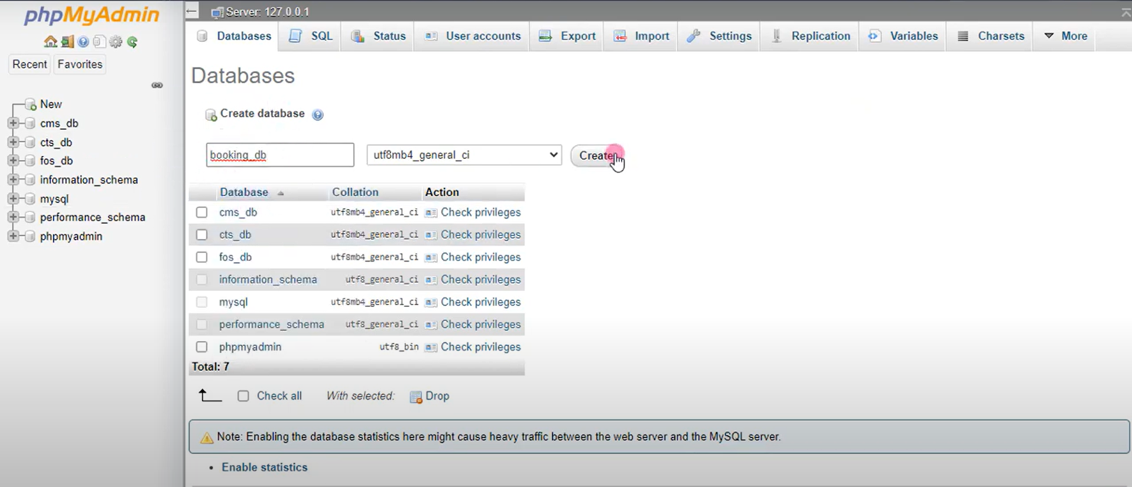

21CS033,Vrushali Mhaskar :

## How it Works

1. First, the user/client must wait until the Reference Number generation is done.
2. The user will click the "Done! Proceed" button to reserve a ticket.
3. The user must fill in his/her "Travelling and Booking Information".
4. Next, he/she must fill in the "Contact Information Details" Form.
5. The user will select his/her method of payment for the "Payment and Verification" step.
6. Then, the user will review and confirm what he/she provided.
7. Lastly, Print the generated ticket.

This project was developed using PHP, MySQL Database, HTML, CSS, Javascript (jQuery), and Semantic UI for the design.

